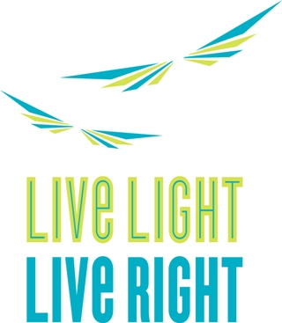

LLLR Partners With the Brownsville Recreation Center
To bring you
Knockout Obesity Boxing Class

Please join us for a Knockout Obesity boxing class; LLLR and the BRC are working together to bring new and fun fitness class to you.

Knockout Obesity (www.koobesity.com), The “KO Program” is reaching out in the community to bring physical activity and nutrition education. The KO mission is to combat childhood obesity by providing nutritional and physical education, and programming, using the tenets of boxing, while partnering with private and non-profit organizations to reach both youth and adults in need.

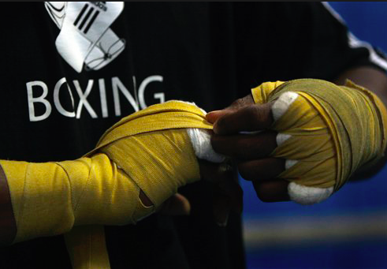
Where:
Brownsville Recreation Center
1555 Linden Blvd, Brooklyn, NY 11212

When:
Saturday, October 25, 2014
10:00am to 11:15am

Please RSVP to Rena at 718-240-8125
Open to all children

We look forward to seeing you there. Please let us know how you like the class.

